Of Time And The City, Cannes 2008 – selected Press

From The Times
May 22, 2008
Top Ten Cannes Festival films
Of Time and the City
A lump comes to the throat when this film is mentioned anywhere on the Croisette. It is a modest, low-budget sensation. It is a film poem about Terence Davies’s life and the city he grew up in – Liverpool – that will make you howl with laughter, and then cry. Narrated by Davies himself, the film is a montage of thoughts and terraced streets. We see new slums being built before our eyes. The camera crawls up the Corinthian columns of City House like someone lifting the hem of a dress. This is film-making of the first order. (James Christopher)

'Of Time and the City' is a poetic masterpiece from Britain's Terence Davies, argues Geoff Andrew
While Cannes Official Competition entrants are still, for the most part, tending to impress rather than overwhelm – there’s plenty of perfectly good fare (Walter Salles’ ‘Linha da Passe’, Matteo Garrone’s ‘Gomorra’, the Dardennes ‘Lorna’s Silence’), but no masterpiece as yet – the out-of-competition strands are producing some gems: two such in Un Certain Regard are Raymond Depardon’s documentary about French farmers (‘La Vie Moderne’) and Andreas Dresen’s tale of elderly adultery (‘Cloud 9’). But the one truly great movie to emerge so far has been Terence Davies’s ‘Of Time and the City’; it’s not only this writer who considers it some kind of masterpiece. Davies has waited far too long for financing since ‘The House of Mirth’, made eight years ago, and even when the money came his way it was a relative pittance as one of three commissions designed to mark Liverpool’s brief period as European Capital of Culture. Not, you’d have thought, the most fertile offer to come Davies’s way, but, master of the cinematic art that he is, he responded to the challenge magnificently, making the most of a constrained subject matter and limited resources. What he came up with could have been overly specific and utterly self-indulgent – a reminiscence/meditation on his own experiences of and relationship to Liverpool – but this ‘documentary’ is as personal, as universal in its relevance, and as gloriously cinematic as anything he has done. Basically, the film consists of archive footage of Liverpool and the Merseyside area, spliced together with some new footage shot by Davies, and juxtaposed with a soundtrack that includes Davies’s own voice – reading his own words and those of others – fragmented recordings of others’ voices, a bit of radio and an astonishing broad array of music. It could all have been dull as ditchwater, but with Davies’ proffering TS Eliot and Emily Dickinson, Round the Horne and Grand National coverage, Mahler and the Hollies, Peggy Lee and composers this music-lover had never even heard of (not to mention a few wonderfully irreverent jokes), and using them to put the images into all manner of rich and strange perspectives, the film is quite, quite magical from start to finish. It’s not really like anything else – except, of course, Davies’s other films – which is probably why Cannes director Thierry Frémaux wisely chose not to show it as part of the Official Competition. Watching the film, you realise that Britain has no other filmmaker to match Davies in terms of his purely cinematic sensibility. Fine as our other far-from-inconsiderable big names are, it’s hard to imagine any of them creating sheer filmic poetry as may be found here. Davies’s juxtapositions of music and image, especially, are consistently audacious, original and exhilarating, whether the compositions reflect and reinforce each other or whether they make more complex by way of superbly sharp irony. It’s hard, on paper, properly to evoke the effect of watching Liverpool’s architectural transformation to a city of soulless ’60s high-rises while hearing Peggy Lee singing ‘The Folks Who Live on the Hill’ – suffice to say that countless feelings, thoughts and memories come to mind. And this is above all a film about memory, and time’s passing, and ageing, and loss; it’s about Liverpool only in so far as it's what Davies recalls from his early years, and what he left behind, even though it will always remain deeply embedded in his make-up. In the end, like all films with something that speaks to us all, ‘Of Time and the City’ is wholly specific in its origins. It’s about Davies, it’s about Liverpool, it’s about Britain and how it’s changed in the last century, and it is about what it means to be a sentient, intelligent – and, mercifully, in Davies’s case, witty – human being. O tempora, o mores… Oh, what a magnificently beautiful movie!

Evening Standard – 20th May 2008
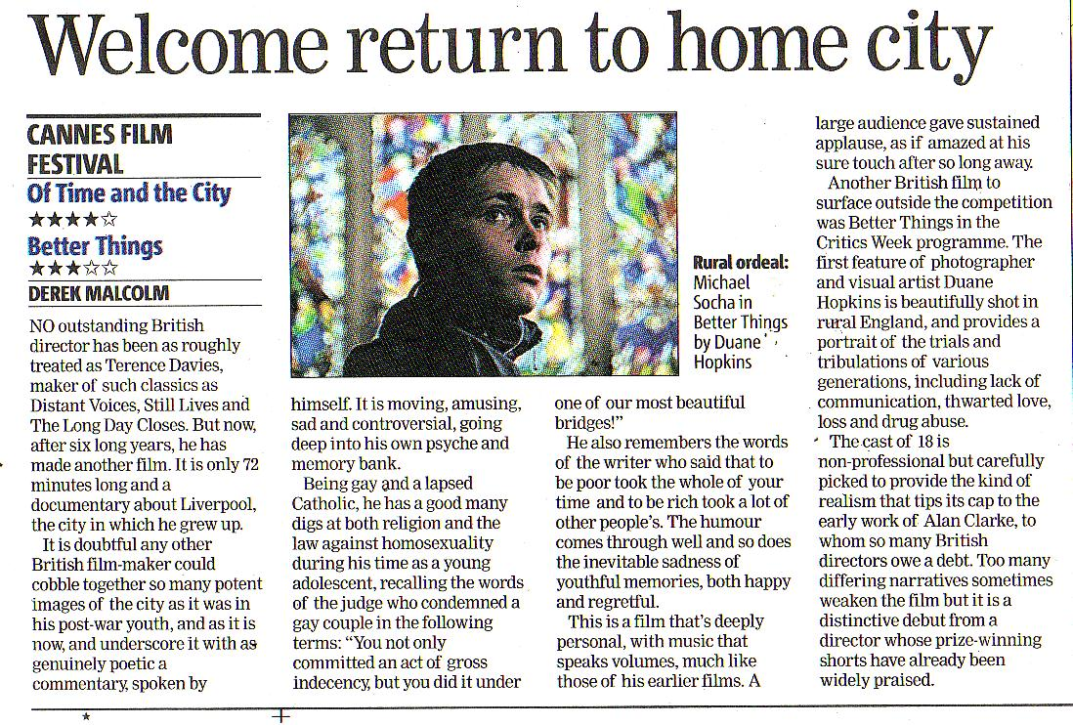

Liverpool film portrait takes Cannes Film Festival by storm

May 21 2008 by Mike Chapple, Liverpool Daily Post

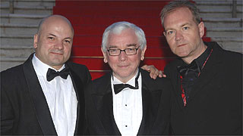
Producer Sol Papadopoulos, Director Terence Davies and Producer Roy Boulter on the red carpet at Cannes

LIVERPOOL-BORN director Terence Davies’s new film about his home city is taking the Cannes Film Festival by storm after receiving rave reviews from the assembled world’s press out there.

Of Time and The City, which received its world premiere last night, is being acclaimed as a masterpiece after a star-studded red carpet ceremony last night in the French resort.

“This is a big coup, fantastic, because this beautiful, very moving, film is absolutely all about Liverpool,” said Alice Morrison, chief executive of Northwest Vision and Media (NWVM). “It resonates with everything about the city and its people and is especially exciting because this is happening in the Capital of Culture Year.”

NWVM produced the film as part of its Digital Departures initiative, a competitive scheme coordinated with the culture company, the UK Film Council and the BBC, which has supported three feature projects filmed in Liverpool for 2008. The other two are Salvage and Starstruck, both of which are being promoted at the festival.

But Davies’s 72-minute film, which has been produced by Liverpool company Hurricane Films, based on Hope Street, has already been snapped up for UK distribution by the British Film Institute (BFI) with international sales being handled by HanWay Films.

The BFI’s head of Content Development, Jane Giles, said last night: “The BFI has had a long and fruitful relationship with Terence Davies. His work is pure cinematic poetry.”

The film is a deeply personal evocation by Davies of his life growing up as a Liverpudlian in the 50s and 60s using gritty documentary footage supplemented by his own commentary voiceovers and appropriate musical soundtracks. The 62-year-old is renowned for his autobiographical works of Liverpool times past, the films Distant Voices, Still Lives and its sequel The Long Day Closes having already won global acclaim.

His latest, although it is not in competition, is one of a handful of films chosen by the Cannes judges for a prestigious Special Screening and one of only two British films chosen for the whole festival. The other is Hunger, Steve McQueen’s dramatisation of the last days of the IRA’s Bobby Sands.

Following its Cannes screening, Of Time And The City heads for the Edinburgh Film Festival before a Liverpool premiere scheduled for October.

What the Cannes critics say

THE one truly great movie to emerge so far (from Cannes) has been Terence Davies’s Of Time and the City; it’s not only this writer who considers it some kind of masterpiece... this film is as personal, as universal in its relevance, and as gloriously cinematic as anything he has done.

TIME OUT

Davies's film is made of old documentary footage, brilliantly illuminated by music and his commentary. It intertwines Davies' own story with the story of the redevelopment of his home town of Liverpool. It pivots around a sequence that shows utopian tower blocks being built and then falling into decay, to the tune of Peggy Lee singing The Folks That Live on the Hill. It's an elegant, angry sequence that tells a story recognisable to anyone who grew up in a city after the war.

THE GUARDIAN

For my money, this is a British masterpiece, a brilliant assemblage of images that illuminate our past. Not only does it tug the heart-strings but it's also savagely funny.

DAILY TELEGRAPH

There’s a similarity of tone to James Mason’s narration in the 1967 film The London Nobody Knows, another portrait of a changing city that would make a rewarding double bill with this regret-filled love letter to Liverpool.

The Times, 20 May 2008

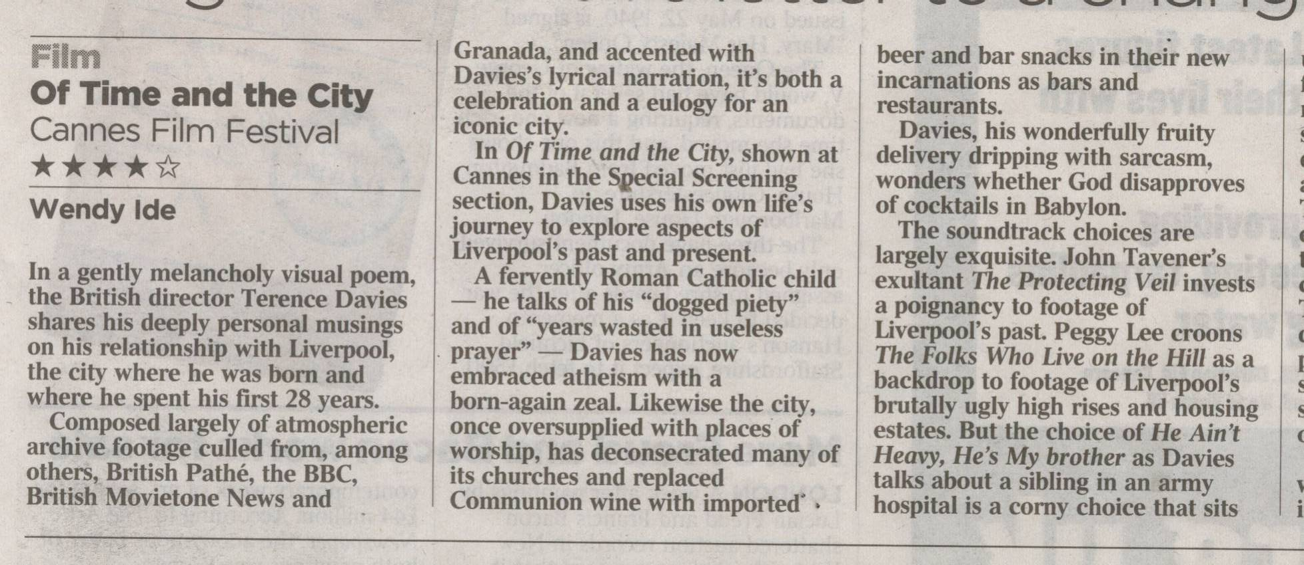
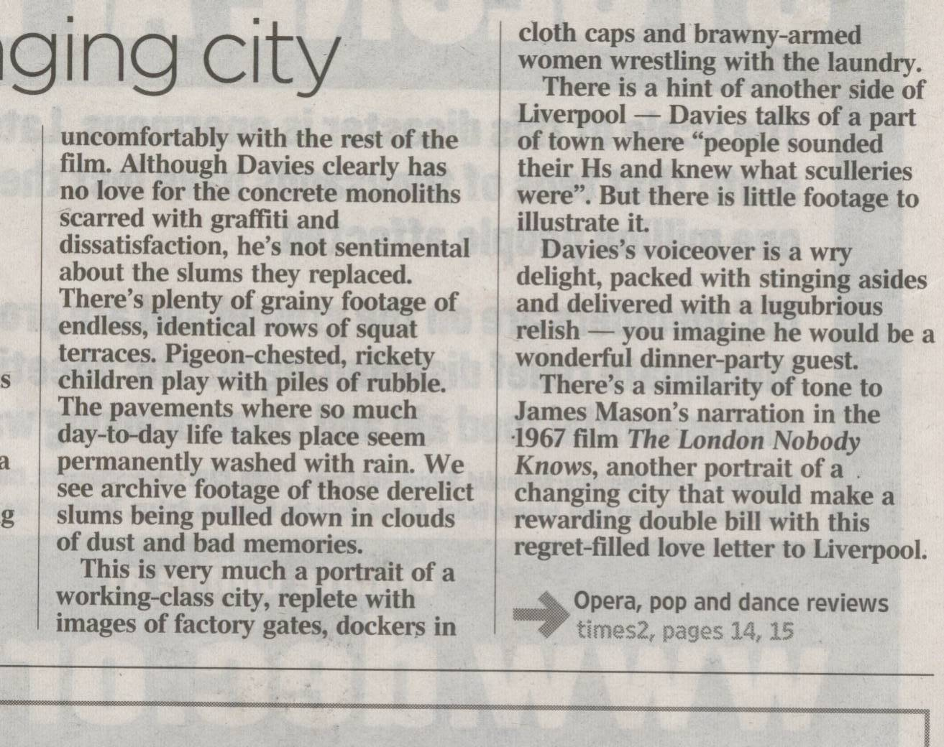

A Northwest Vision and Media & Digital Departures presentation in association with the Liverpool Culture Co., BBC Films of a Hurricane Films Production. (International sales: Hurricane Films, Liverpool.) Produced by Sol Papadopoulos, Roy Boulter. Executive producers, Christopher Moll, Lisa Marie Russo.
Directed, written by Terence Davies.

Variety

After a regrettable eight-year absence from filmmaking, Brit helmer Terence Davies returns with "Of Time and the City," a highly personal film essay about his hometown, Liverpool. A collage of archive material and original footage is fused with distinctive musical choices and a rhapsodic voiceover by Davies himself that cogitates on themes familiar from the helmer's work. Result is by turns moving, droll and charming, and niftily assembled, but not necessarily that profound. Outside Blighty, distribs may feel not quite enough time is spent in the city itself (pic runs 77 minutes) to justify theatrical runs, confining pic to fest and tube play.

Pic's structure is based neither on strictly chronological nor thematic criteria; rather, free association is the order of the day here, as images, music and voiceover narration work together to blend the macro and the microcosmic perspectives, laying personal memories side by side with, literally, a bird's eye view on the city. A same, associative principle that governed Davies' earlier feature work ("The Terence Davies Trilogy," "Distant Voices, Still Lives," "The Long Day Closes"), in which events seldom happen in order and instead seem to tumble out of a narrator's brimming mind, is at play here. Parallels could be invoked with other essayist-filmmakers, such as Patrick Keiller (whose "London" this picture recalls in its intellectual scope), Humphrey Jennings ("Listen to Britain") and Derek Jarman.

Take, for instance, the opening sequence, wherein shots of Liverpool's Walker Art Gallery in all its neo-classical, colonnaded splendor segue into images shot inside a Catholic church, while the voiceover contemplates returning to the past, quoting A.E. Housman's lines about a "land of lost content." Next, archive footage from the earliest days of cinema shows trains moving through lost streets as Davies intones Percy Bysshe Shelley's "Ozymandias," another elegy for a lost civilization. Much of the voiceover's poetry, incidentally, is not attributed and simply blends in with Davies' own ideas. (Perhaps viewing the film could form the foundation for a drinking game among literary scholars, prompting participants to take a swig every time they spot a quotation in the mix.)

In fact, "mix" is just the word for Davies' project: He layers sounds -- snatches of archive recordings and music, for example -- on top of each other, reminiscent of the way hip-hop producers and DJs mash up songs and samples. (Davies would probably hate this comparison, given his confession here to disliking pop music that came after the arrival of rock 'n' roll.)

Other key sequences, which will seem comfortingly familiar to Davies fans, include hymns to the power of Hollywood cinema, the church that replaced the Church in helmer's heart, archive footage of working-class people performing quotidian rituals (shots of women washing windows evoke a crucial sequence in "Distant Voices, Still Lives"), and spectral voices from the past, variously snatches of radio programs like the camp 1960s radio show "Round the Horne," or of an anonymous woman recalling how she was made an orphan by the death of her mother and sailor father.

Weaving in and out, Davies sketches in bits of his own autobiography and personal opinion. A memory of the annual exotic pomegranate he got in his Christmas stocking each year as a child holds the same weight as a deliciously mocking description of Queen Elizabeth II's wedding, described as the "The Betty Windsor Show." Irony is much to the fore, with images and sound abrading off one another, like when Peggy Lee's version of "The Folk Who Live on the Hill" backs a montage showing how the squalid Victorian terraces of the poor gave way to the squalid, 60s-built brutalist tower blocks of the poor.

The cumulative effect is very entrancing as it unspools, but once the lights go up some viewers may feel a little short-changed. For all the sensuousness of the experience, Davies doesn't really have that much to say specifically about the city of Liverpool itself, particularly in its present state as it undergoes, like many of Blighty's provincial metropolises, a profound shift from industrial to service-sector economics. The emphasis on the working-class culture of the past teeters at times on the banal. It's to the city's credit that its funding bodies and those of the region put money into the pic, despite these lacunae.

All the same, praise is due for pic's polished sheen, from the standout musical choices, to the oneiric editing, to the helmer's rich, narrating baritone itself. The archive research, credited to Mike McKibben and Angela Byrne is worth the price of admission alone.
More than one option

Camera (color), Tim Pollard; editor, Liza Ryan-Carter; music, Ian Neil; sound (Dolby Digital), David Coyle, Steven Guy. Reviewed at the Cannes Film Festival (Special Screenings), May 19, 2008. Running time: 77 MINS.



Dir: Terence Davies. UK. 2008. 74mins.

Over the decades many accomplished directors have created cinematic odes to cities dear to their hearts. Berlin (Walter Ruttmann, from the silent era); Paris (Je T'Aime, particularly Alexander Payne's segment), and Rome (Fellini). But Liverpool? You have to hand it to Terence Davies. Although he has not made a film since 2000's The House Of Mirth, he has successfully constructed an outstanding work about the hometown he may have left behind but has clearly not ceased to haunt him.

Davies accessibly structures what is almost entirely archival footage and narrates the scenes himself using his own memories and observations, infused with a dose of sarcasm and camp. Both local and universal, Of Time And The City, at just 72 minutes, could work on television or DVD, and not just in Britain - although creative marketing is a necessity.

Davies has always been fascinated by both out-of-reach glamour and the banality of everyday life. Here he shifts seamlessly from one to the other, moving the film briskly along in the process. He begins and ends with a false movie screen accompanied by the theme music to Douglas Sirk's 1956 All That Heaven Allows and projects onto it the most ordinary shots of old Liverpool. Revisiting what he calls "the happy highways where I went and can not come again", is obviously cathartic for Davies, even if melancholy seeps through every frame.

Without judgment, he shows and discusses everything from busy washerwomen to over-decorated Catholic churches (he may term himself an atheist now but the Church has been a tremendous influence on his life and films), slum housing, wrestling matches, rusty steel bridges, and the ugly urban renewal projects that replaced much of the inner city in the 1960s. For him all are significant pieces of the puzzle. The Beatles get short shrift, however, getting no more coverage than children at the public pool or the old women at the tea shop.

To his credit, Davies does not isolate Liverpool from the nation, indeed the world. He talks about "the Betty Windsor Show" - Queen Elizabeth's ostentatious marriage during a time of rationing. He does not ignore aspects of himself that others might choose to gloss over. He constantly alludes to his homosexuality, whether directly or through gay-inflected humour. Like its director, Of Time And The City is honest and open, censoring nothing in a sincere if relentless quest for truth.

Production companies
Hurricane Films
Northwest Vision and Media
Digital Departures
Liverpool Culture Company
BBC Films

International sales
HanWay Films
(44) 20 7290 0750

Producers
Solon Papadopoulos
Roy Boulter

Screen play
Terence Davies
Cinematography Tim Pollard Editor
Liza Ryan-Carter Music
Ian Neill

From The Times
May 20, 2008
Of Time and the City
A regret-filled love letter to a changing city Wendy Ide
In a gently melancholy visual poem, the British director Terence Davies shares his deeply personal musings on his relationship with Liverpool, the city where he was born and where he spent his first 28 years.
Composed largely of atmospheric archive footage culled from, among others, British Pathé, the BBC, British Movietone News and Granada, and accented with Davies’s lyrical narration, it’s both a celebration and a eulogy for an iconic city.
In Of Time and the City, shown at Cannes in the Special Screening section, Davies uses his own life’s journey to explore aspects of Liverpool’s past and present.
A fervently Roman Catholic child – he talks of his “dogged piety” and of “years wasted in useless prayer” – Davies has now embraced atheism with a born-again zeal. Likewise the city, once oversupplied with places of worship, has deconsecrated many of its churches and replaced Communion wine with imported beer and bar snacks in their new incarnations as bars and restaurants.
Davies, his wonderfully fruity delivery dripping with sarcasm, wonders whether God disapproves of cocktails in Babylon.
The soundtrack choices are largely exquisite. John Tavener’s exultant The Protecting Veil invests a poignancy to footage of Liverpool’s past. Peggy Lee croons The Folks Who Live on the Hill as a backdrop to footage of Liverpool’s brutally ugly high rises and housing estates. But the choice of He Ain’t Heavy, He’s My brother as Davies talks about a sibling in an army hospital is a corny choice that sits uncomfortably with the rest of the film. Although Davies clearly has no love for the concrete monoliths scarred with graffiti and dissatisfaction, he’s not sentimental about the slums they replaced. There’s plenty of grainy footage of endless, identical rows of squat terraces. Pigeon-chested, rickety children play with piles of rubble. The pavements where so much day-to-day life takes place seem permanently washed with rain. We see archive footage of those derelict slums being pulled down in clouds of dust and bad memories.
This is very much a portrait of a working-class city, replete with images of factory gates, dockers in cloth caps and brawny-armed women wrestling with the laundry.
There is a hint of another side of Liverpool – Davies talks of a part of town where “people sounded their Hs and knew what sculleries were”. But there is little footage to illustrate it.
Davies’s voiceover is a wry delight, packed with stinging asides and delivered with a lugubrious relish – you imagine he would be a wonderful dinner-party guest.
There’s a similarity of tone to James Mason’s narration in the 1967 film The London Nobody Knows, another portrait of a changing city that would make a rewarding double bill with this regret-filled love letter to Liverpool.



CANNES: Memory twists and turns, peering into this and that dark corner in Wong Kar Wai's "Ashes of Time Redux" and Terence Davies's "Of Time and the City," two beautiful entries at this year's Cannes Film Festival. The selections, both screened out of competition, find each director working through the past, with Wong revisiting one of his older features, the martial arts fantasia "Ashes of Time" (originally released in 1994) and Davies returning to Liverpool, the city of his birth and the backdrop for his earlier autobiographical films, including the haunting and haunted "Distant Voices, Still Lives" (1988).

"Of Time and the City," one of three movies commissioned to celebrate Liverpool's having been chosen as Europe's Capital of Culture in 2008, marks a welcome return to filmmaking for Davies after an interminably long eight-year absence. His magnificent adaptation of Edith Wharton's "House of Mirth" died a cruel box-office death in 2000; his last film at Cannes, in 1995, "The Neon Bible," fared as poorly. At once a symphony of the city and a memento mori, intensely site specific and yet of general interest, "Of Time and the City" seems bound for a long festival tour, having received an enthusiastic welcome after its first screening.

Davies narrates the fleet 72-minute film in a gravelly rumble that conveys as much through his delivery (arch, amused, enraged) as through his words (poetic, ruminative, elegiac). In that short, even too-short time, he ranges far and wide through both the city and its history, waxing personal and then political as he lingers at the movies (an early love), pauses in bleak homes and passes through one grim brick-lined Liverpudlian street after another, strewn with litter and busy with children. Mixing his words with quotations (from Friedrich Engels to Willem de Kooning), pop songs and classical music, he brings the past sensitively to life with black-and-white and color footage of a time long gone, both distant and still.


The King of Cannes
By Nick Roddick, Evening Standard 23.05.08

Terence Davies, regarded by many as Britain's greatest living film director but whose career has been stalled for almost a decade, was radiant with happiness, indeed almost glowing, in Cannes earlier this week, his already ruddy complexion heightened by the intermittent Riviera sun.

No wonder he was so happy - he was back in Cannes for the first time in 12 years and with a new film, Of Time and the City, which has been attracting rave reviews from the critics. "I don't really believe it's happening, truly I don't," says the director, resplendent in black tie, a glass of champagne in his hand.

The last time Davies was here was in 1996 with a film called The Neon Bible, based on a John Kennedy Toole novel set in the American Deep South. But it got mixed reviews.

His two previous Croisette outings, however, Distant Voices, Still Lives and The Long Day Closes - both strongly autobiographical, both gorgeously poetic, and both backed by the British Film Institute's nowdefunct production fund - were received with something approaching critical rapture.

The first won the Critics Prize at Cannes in 1988, the second the Evening Standard Best Screenplay Award four years later. Another long gap followed until, in 2000, Davies and his producers were finally able to raise the money - though not much - for The House of Mirth, based on the Edith Wharton novel, shot on a shoestring in Glasgow and starring Gillian Anderson as a New York socialite at the turn of the 20th century who is torn between love and the search for security. Since then, nothing.

Until this week. Now Davies is not just back: this week, he became the unlikely King of Cannes following the special screening of Of Time and the City, an essay on and tribute to his native Liverpool that is both passionate and melancholy and has had an impact almost unheard of for a 72-minute documentary made for £250,000 (which, in the film business, is tea money).

Of Time and the City, which is not in competition for any of the prizes announced on Sunday, has surprised everyone, including Davies, by becoming one of the hits of a lacklustre festival.

"I never thought we'd go to Cannes," he says. "And when they invited me, I was just amazed. I thought, well, you know, maybe a little private screening or something ... I never thought it would have this kind of response.

"I've been talking to people from all over the world about it," he adds, throwingup his hands in mock amazement. "I mean, people from Montenegro!"

He pronounces the last word with camp relish, as though it were the punchline in one of the Julian and Sandy sketches from Round the Horne - a programme dear to Davies's heart.

But while Davies freely admits that the Montenegrins didn't get Julian and Sandy, he insists that it's not just the Brits who have responded to the film.

"What I believe is, if something is true, genuinely true, then it doesn't matter where it's from or where you come from. You don't have to be Norwegian to appreciate Ibsen, you don't have to be German to understand Schubert. If it's true, we recognise it, even beyond language. I do believe that!"

Davies's own use of language is one of the distinguishing elements of his work: now poetic, now camp, occasionally scatological. The same is true of his conversation.

I ask him if he was nervous about going up the famous steps of the Cannes Palais in front of the world's television cameras. "Oh yes," he says. "I'm just as nervous as I always was as an actor going in front of an audience. But Imodium helps no end! It's the pill that gives and gives."

Davies has made an art form of hiding his passion (and sometimes his pain) behind a string of hysterical anecdotes, some borrowed, some blue, some possibly true. Talking of his struggle to make The House of Mirth, he recalls meeting Martin Scorsese, who had made his own Edith Wharton adaptation, The Age of Innocence, in 1993.

"Seeing our little film alongside that was a bit like being in a production of Joseph and the Amazing Technicolor String Vest," chortles Davies. "But Scorsese was very nice so I asked him what he was going to make next. He said he was going to do a film about the Dalai Lama. Well! I couldn't stop myself ! I said: 'What are you going to call it? Hello, Dalai?'"

Davies talks in little rushes of words, the emphasis always falling where you would least expect it, the whole wrapped up in a breathy delivery - "it's the asthmatic in me," he explains - that is the verbal equivalent of grabbing you by the elbow (which he also does).

What's more, for all the two-uptwodown terraced houses of his childhood (and his early films), there is not a trace of Liverpool in his voice. "I've got a very acute ear," he claims. "When I was a child, I listened to people who spoke posh and I just imitated them. People used to ask me: 'When did you lose your accent?' I asked my sister Maisie and she said: 'You never had one!'"

Nowadays, Davies is the quintessential Englishman abroad, dressing (when not in evening attire) in jacket and tie amid the bling-casual of Cannes, his white hair neatly combed, shoes smartly polished. His mum - who died in 2004 and whom he says he "misses every day" - would have been proud.

"Mmm," he says when I ask him about his Englishness. "Mmm. I don't mean this in a jingoistic way but I'm very proud of my country. I think we've done things any other country would trumpet from the rooftops. We produced the world's greatest playwright, our poetry is second-tonone, and we invented the novel."

But it is not an uncritical pride. He is, for instance, fiercely resentful of the royal family, describing them in the film as "Betty and Phil". "I think they're parasites, I just do," he exclaims.

And he lost interest in popular culture circa 1962 (his passing reference to The Beatles in Of Time and the City is hilarious), peppering the film's lush soundtrack with songs from Hollywood musicals, classical music and, somewhat surprisingly, the Hollies' He Ain't Heavy (He's My Brother).

In fact, Davies seems slightly out of place in the modern Britain of binge drinking, bendy buses and football: his soul remains fixed in the Fifties. Of today's English, he says: "I'm appalled at our neolithic behaviour, both at home and abroad. And our use of language is appalling - estuary English, so glotally stopped that you need subtitles! It's because I'm proud of my country that I'm its most rigorous critic. But I think there are things that we still have that we should treasure."

Britain has not exactly treasured Davies. At 62, he has made just four features, plus a sublime trilogy of short films (recently released on DVD) and now this new documentary.

His career was not helped by the UK Film Council's refusal, a couple of years back, to put in the last small tranche of money needed to complete the financing of an adaptation of Lewis Grassic Gibbon's classic Scottish novel, Sunset Song.

Already in pre-production, the project collapsed (though he now hopes to revive it). When the Film Council snubbed him, Davies certainly didn't grin and bear it: he took every chance to complain, and I've heard him say things about the then head of the Film Council's Premiere Fund, Robert Jones, that the laws of libel prevent me from repeating here.

But the Film Council did contribute to Of Time and the City, one of a trio of films celebrating Liverpool's European Capital of Culture year.

What's more, with a sense of spin redolent of its New Labour origins, the organisation rode the wave of acclaim that greeted the new film by announcing, the day after its Cannes premiere, that it would be backing Davies's next project, a romantic comedy called Mad About the Boy.

For the moment, the director is keeping his powder dry on that one. "I'll believe it when I have the crew together," is all he will say for the moment. He's not afraid to duck a fight - this week, he has attracted controversy for criticising other British filmmakers' work as "sub-American nonsense".

However, he does seem to have kissed and made up with the Film Council. "The new regime are completely different," he claims, "not because they're helping me, which obviously I'm pleased about, but because they love films, they know about them and they care about them. That makes a huge difference. When I talk to Lenny Crooks [who has replaced Jones as head of the Premiere Fund], he's passionate, absolutely passionate about it.

"That restores my belief, because if there's no passion, there's no point in being alive."

He pauses, tugging at his collar, to ask if we can move to a slightly cooler end of the Cannes bar where we have been talking. We stand in the small tabled area by the street, along which the Festival's incessant stream of onlookers is trudging by. Spotting my tape recorder held up to a man in a dinner jacket, several people stop.

Someone takes a photograph. Admittedly, photographs will always be taken in Cannes if a small crowd has gathered, in the hope that someone there might prove to be famous. But I quickly realise the photographer knows what he is doing: as he walks away, I hear him say the word "Liverpool".

Terence Davies, so long forgotten by the British film establishment, is the unlikely king of the Cannes Croisette in May 2008.

A walk through the city of ghosts
Thursday May 15, 2008
The Guardian

A paean to Liverpool, Terence Davies' new movie burns with anger and regret. Screenwriter and fellow scouser Frank Cottrell Boyce meets him in Merseyside

A couple of years ago, Terence Davies gave an interview to this paper in which he named and shamed the confederacy of film industry dunces who had refused to back his adaptation of Lewis Grassic Gibbon's Sunset Song. It was a pretty exhilarating read - until I got to the end and found one of my own scripts (A Cock and Bull Story) on his list of dunce-funded disasters. So as I slog up Liverpool's Mount Pleasant to meet Davies, I feel like I've been summoned to the head's office to be lectured on the decline of British film and be told it's all my fault.

Half an hour into our meeting and it's much worse than I expected. Davies is asphyxiating with laughter as he struggles to recite his favourite Les Dawson-Roy Barraclough routine. He is going to die, and it's going to be my fault. I can see tomorrow's headlines: "Greatest living film director found dead in hotel - hack with grudge apprehended at scene." Davies laughs like a tickled toddler. The bitter, angry genius of that interview has been replaced by a generous, light-hearted genius. Who rearranged Davies' DNA? A small Liverpudlian production company called Hurricane Films, who managed to get him what he needed: a movie. A movie that is going to Cannes. A movie that is among his best.

Of Time and the City intertwines Davies' own story with the story of the redevelopment of his home town of Liverpool. It pivots around a sequence that shows utopian tower blocks being built and then falling into decay, to the tune of Peggy Lee singing The Folks That Live on the Hill. It's an elegant, angry sequence that tells a story recognisable to anyone who grew up in a city after the war. There must be millions of us with memories of an "old house" in the city that was abandoned for a new life in the suburbs or the estates.

Davies' film is made of old documentary footage, brilliantly illuminated by music and his commentary. I found myself scanning it for faces and places I knew. Sure enough, there's the block of flats where I spent my first years. There's even a little boy drawing on a doorstep that I am sure is me. Flushed with the feeling that our shared city is a common bond, I ask him what it's like to be home. "Well, it's not home," he says. "It's changed so much I feel like an alien." Changed for the better? "Well, it couldn't have been worse."

He tells a story about making his first film here. A group of men stopped and chatted to him about what he was doing. Davies recognised one as someone who had made his life hell at school. "But he didn't recognise me. He'd inflicted all that suffering. It was nothing to him." He almost flinches. It's obvious from watching his films that Davies is someone whose childhood memories are unusually vivid and raw. For him, coming back to Liverpool is like Dante just taking one more peep into the Inferno.

We talk about the business of leaving. For me, being moved out into suburbia made Liverpool a magical place - of childhood and forgotten ways. I couldn't wait to move back in. But you don't recapture the magic by moving back.

You lose it. The magical "old house" turns out to be just another house. The terrifying bully turns out to be smaller than you thought with problems of his own.

Davies, on the other hand, seems hypnotised by his memories. For Of Time and the City, he searched through miles of footage, looking for moments that resonate for him. There are shots of women carrying massive bundles home from the bag wash on their heads: "I thought, 'Yes, I remember that, and the way the house felt so empty on wash days because the curtains were down.'" The resulting movie is something both personal and universal. A crowd piles onto a New Brighton ferry in black and white, then spills off again in colour. Children run around some wasteland to the sound of Mahler, the familiar image aglow with loss. Stock footage of the Coronation crackles with energy as Davies - unexpectedly - lays into the monarchy.

I watched it with a friend who said it was like Dylan Thomas ("Christmas gobstoppers that lasted till August") meets the Sex Pistols, a comparison Davies would hate. Davies is the first person I've met in a long time who openly detests pop music. He's sure the world was a better place before 1963. I tell him I'm amazed by the size of the crowds in his film: the Kop, the ferries and the streets look like they're sinking under the weight of bodies. He immediately replies: "Yes, and they were all so proper."

If that makes him sound smug or curmudgeonly, he's not. First of all because he's so civilised. He loves poetry, especially TS Eliot's Four Quartets, which he used to shape Distant Voices, Still Lives. I try to keep a straight face - but imagine pitching that to the Film Council today. "I can only do what I feel," says Davies. "Imagine if I tried to do an action movie: two cars moving towards each other very slowly and then fading away." He loves the detail in Betjeman and tries to recite Hunter Trials. I tell him, "Actually, Terence, that's my wife's party piece. I'll get her to do it for you later." "Will she do it with a lisp?" "Try and stop her."

It's like talking to the master of a forgotten craft. He glows when he describes his favourite shots, such as the amazing cross-fade to the city in FW Murnau's Sunrise. "It was done in the camera. Imagine that!" The terrifying image of Robert Mitchum silhouetted and singing on the horizon in Night of the Hunter. "They used a child on a donkey instead of Mitchum on a horse, to exaggerate the perspective." And he loves old studio movies, especially Singin' in the Rain.

It strikes me that the thing that makes his work extraordinary is that he has taken the techniques and production values of the back lot and the sound stage - and used them to tell stories about people who are normally shown as either comic relief or as social problems. He shoots his mother washing the windows of his terrace house with all the lavish attention of Rouben Mamoulian shooting Greta Garbo. He shoots working-class people as if they've got souls. There's a moment in Of Time and the City where an old lady lists all the hardships she's endured and then thanks God. It's like listening to a raw psalm.

As a child, Davies was a pious boy who lost his faith to the harshness of the pre-Vatican II era and his struggle with his own sexuality. But the glamour and precision of old Hollywood seems to have taken on the job that incense and candles used to do: the job of finding a door from the terraced house into the sublime. And his work is as dedicated and detailed as a monk illuminating a manuscript. I ask why he built a set for Distant Voices, instead of just shooting it in a street. "Well, there very few streets with two-storey houses on one side and three on the other, so obviously you had to build the set." I'm not sure how obvious that is, Terence. I think I might have made do with two storeys on both sides. As I might have made do with New Zealand birdsong in The House of Mirth (he famously had the incidental birdsong removed from the soundtrack so that he could dub on some more accurate twitters).

I suppose this makes him difficult to work with. He's not just trying to make a film, he's trying to make good his losses; to recreate what he lost. As a business plan, it's a non-starter. Maybe that's why people hesitate to back him. But it's also what makes him a great artist. And if the Film Council doesn't back Davies, then what is it for?

My wife turned up later and recited Hunter Trials for him. He sat there beaming, like a boy whose mother was reading him a bedtime story. Unless ye become as little children, I thought. And that's what Davies is. He's as foolhardy, clearsighted and uncompromising as a child. And that's why we should be looking after him a bit. And if we do, he'll tell us the truth. Just like children do.

Of Time and the City premieres at Cannes on Tuesday. It will be released in the UK in November

Posted by Ty Burr May 19, 2008 11:57 AM

The British filmmaker Terence Davies doesn't come out with new work very often -- he's only made five features in 24 years -- so "Of Time and the City" is something of an event. And even though it runs a brief 72 minutes, this documentary memory play about Davies' hometown of Liverpool is so rich with emotion, nostalgia, clarity, and love that it feels epic. Davies himself narrates over the inspired onrush of historical and archival footage, and his hoarse, whispered cadences have the urgency of the confessional and the scornful humor of the outsider. Hear him sneer delightedly at the ascension of Queen Elizabeth II, aka "the Betty Windsor Show," or mock "the British genius for creating the dismal" over images of post-war housing projects and their awful decay.

"Of Time and the City" (here's the offical website) uses music brilliantly, especially in a section that stitches together a day in post-WWII Liverpool from archival footage and sets to achingly beautiful medieval polyphony (Perotin's "Beata Viscera," to be particular). Note to rockers: Davies could care less about the Beatles. No idea if the film will get picked up for U.S. release, but it's easily the most haunting work I've seen at Cannes. "We love the place we hate, we hate the place we love," Davies narrates. "Come closer now and see your dreams. Come closer now, and see mine."

Capital of Cannes ...

May 23 2008 by Greg O'Keeffe, Liverpool Echo

A film about Liverpool wowed the critics at Cannes this week. Greg O’Keeffe reports

IT IS the Liverpool documentary which has taken the Cannes Film Festival by storm and earned gushing reviews from London to New York.

Of Time And The City has even re-launched the career of its Liverpool-born director who was once voted one of the most significant film-makers of all time.

Now the mostly black and white picture, filmed on a modest budget with Capital of Culture money, is being coveted by some of the world’s biggest and most respected movie festivals.

It is undoubtedly champagne-popping time for director Terence Davies and producers Roy Boulter and Sol Papadopoulos who, only 12 months ago, were waiting to hear whether their project would receive any funding at all.

Fresh from rubbing shoulders on the red carpet with Gwyneth Paltrow and Tim Robbins, the trio have just arrived back in Liverpool to deal with the huge international interest their hot-property hit has created.

Roy, who runs Hope Street-based production company Hurricane Films with Sol, says: “It’s all still sinking in. The press screening in Cannes was the first time the film had been shown publicly at all, so even though we knew we’d made a good film we didn’t know quite what to expect.

“Normally you’ve got writers coming in and out and quite a bit of chatter but this was different. The whole auditorium was full and people were laughing and watching intently.

“Afterwards they gave it a standing ovation and that was just from the film critics. Since then we’ve had 24 international film festivals contact us with offers.”

The 72-minute documentary is a collage of gritty newsreel footage, video and still images accompanied by Davies’s musical choices and profound narration.

An ode to the post-war Liverpool of his 1950s childhood, it is also the director’s first film in eight years.

It encompasses the great changes Liverpool has been through and explores the stories of the ‘forgotten generation’ of servicemen from the city who fought in the Korean conflict.

Reviewers, who have already labelled the film a classic, praised its sense of humour, tenderness and politics while describing it as a “fascinating portrait” of a city; a city which Terence, 62, barely recognised when he returned to begin filming last year.

Terence, whose last film was The House Of Mirth in 2000, grew up in Kensington Street but left Liverpool for drama school in 1973. He has said: “The city I grew up in and still love in my heart has disappeared”.

He is renowned for his autobiographical works of Liverpool times past, the films Distant Voices, Still Lives and its sequel The Long Day Closes also won global acclaim.

He will return to Liverpool for the world premiere of the Cannes hit at the Philharmonic on October 9.

Roy, who also plays drums for The Farm, spent the evening after the full Cannes screening on Tuesday being approached by film industry moguls offering congratulations.

“We even got a call from Andy Burnham, the cabinet minister for culture media and sport,” he says. “Andy was supposed to come along but couldn’t because he had to stay for the abortion vote in Parliament. He said he had heard great things about it though.

“At the main event we were sat by the Cohen brothers and Tim Robbins, while my wife walked past Gwyneth Paltrow and Sharon Stone.

“Terence has had his next film lined up for a while but he hasn’t been able to get all the funding. Now, after the reception we got in Cannes, he has got all the money together. It’s fantastic.”

Co-producer Sol believes the film has been a hit – even though it is specifically about Liverpool – because it has a “universality” about it.

“Everyone has evocative memories of their childhood and Terence has made a beautiful film about his,” he says.

“We are doing the Edinburgh film festival and the London one which is unusual because usually either won’t feature a film the other has.

“We’ve also had interest from distributors in the U.S. which is remarkable for a very British, very Scouse film. The New York Times and the Boston Herald have both reviewed it and been very complimentary.

“We’re looking forward to the premiere in Liverpool now. It will be a very fitting and proud night.”

North West Vision and Media produced the film as part of its Digital Departures initiative, a competitive scheme coordinated with the Culture Company, the UK Film Council and the BBC, which has supported three feature projects filmed in Liverpool for 2008. The other two are Salvage and Starstruck, both of which are being promoted at the festival.

Time Out rating 4/5
The director of ‘Distant Voices, Still Lives’ is making this autobiographical documentary as part of a scheme linked to Capital of Culture year in Liverpool, his home city.
Movie review

While Cannes Official Competition entrants are still, for the most part, tending to impress rather than overwhelm – there’s plenty of perfectly good fare (Walter Salles’ ‘Linha da Passe’, Matteo Garrone’s ‘Gomorra’, the Dardennes ‘Lorna’s Silence’), but no masterpiece as yet – the out-of-competition strands are producing some gems: two such in Un Certain Regard are Raymond Depardon’s documentary about French farmers (‘La Vie Moderne’) and Andreas Dresen’s tale of elderly adultery (‘Cloud 9’). But the one truly great movie to emerge so far has been Terence Davies’ ‘Of Time and the City’; it’s not only this writer who considers it some kind of masterpiece.

Davies has waited far too long for financing since ‘The House of Mirth’, made eight years ago, and even when the money came his way it was a relative pittance as one of three commissions designed to mark Liverpool’s brief period as European Capital of Culture.

Not, you’d have thought, the most fertile offer to come Davies’ way, but, master of the cinematic art that he is, he responded to the challenge magnificently, making the most of a constrained subject matter and limited resources. What he came up with could have been overly specific and utterly self-indulgent – a reminiscence/meditation on his own experiences of and relationship to Liverpool – but this ‘documentary’ is as personal, as universal in its relevance, and as gloriously cinematic as anything he has done.

Basically, the film consists of archive footage of Liverpool and the Merseyside area, spliced together with some new footage shot by Davies, and juxtaposed with a soundtrack that includes Davies’ own voice – reading his own words and those of others – fragmented recordings of others’ voices, a bit of radio, and an astonishing broad array of music.

It could all have been dull as ditchwater, but with Davies’ proffering TS Eliot and Emily Dickinson, Round the Horne and Grand National coverage, Mahler and the Hollies, Peggy Lee and composers this music-lover had never even heard of (not to mention a few wonderfully irreverent jokes), and using them to put the images into all manner of rich and strange perspectives, the film is quite, quite magical from start to finish. It’s not really like anything else – except, of course, Davies’ other films – which is probably why Cannes director Thierry Frémaux wisely chose not to show it as part of the Official Competition.

Watching the film, you realise that Britain has no other filmmaker to match Davies in terms of his purely cinematic sensibility. Fine as our other far from inconsiderable big names are, it’s hard to imagine any of them creating sheer filmic poetry as may be found here. Davies’ juxtapositions of music and image, especially, are consistently audacious, original and exhilarating, whether the compositions reflect and reinforce each other or whether they make more complex by way of superbly sharp irony. It’s hard, on paper, to properly evoke the effect of watching Liverpool’s architectural transformation to a city of soulless ’60s high-rises while hearing Peggy Lee singing ‘The Folks Who Live on the Hill’ – suffice to say that countless feelings, thoughts and memories come to mind.

And this is above all a film about memory, and time’s passing, and ageing, and loss; it’s about Liverpool only in so far as that what Davies recalls from his early years, and what he left behind, even though it will always remain deeply embedded in his make-up. In the end, like all films with something that speaks to us all, ‘Of Time and the City’ is wholly specific in its origins. It’s about Davies, it’s about Liverpool, it’s about Britain and how it’s changed in the last century, and it is about what it means to be a sentient, intelligent – and, mercifully, in Davies’ case, witty – human being. O tempora, o mores… Oh, what a magnificently beautiful movie!

Author: Geoff Andrew
Time Out Online Cannes Film Festival 2008

Links

Here’s the link to Terence Davies on the Today programme this morning. This shouldn’t effect later R4 coverage. It’s a lovely piece. http://www.bbc.co.uk/radio4/today/listenagain/

http://www.lemonde.fr/festival-de-cannes/article/2008/05/20/of-time-and-the-city-pavane-pour-une-cite-disparue-liverpool_1047136_766360.html#ens_id=995481

